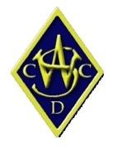

Registration Form

Membership

Please select one of the following:
☐ Summer “Junior Master Class” Camp December 16 and 17 $295
☐ Summer “Master Class“ Camp December 18 and 19 $295

Player Contact Details

Name:
Phone:
Email:
Player Age:

Key Skills to be Developed

☐ Batting
☐ Fast Bowling
☐ Spin Bowling
☐ Wicket Keeping

Parent Details (if under 18)

Name:
Phone:
Email:

Payment Details

Direct Debit: Western Suburbs District Cricket Club
BSB 484 799
Account Number 200724556
Please reference your “APLUS” and your surname in your payment details.

Confirmation of Registration

To confirm your registration and payment, please tick the boxes below, save and return this form by email to westspluscricket@gmail.com.

☐ Registration
☐ Payment

