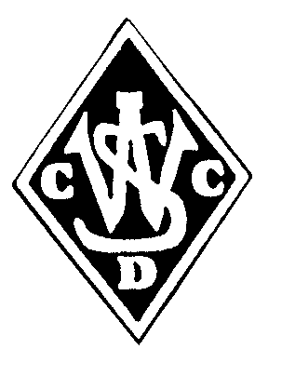 | WEST’S LORD TAVERNER’S TRIAL REGISTRATION
Founded | Players Name:
9th May 1921 | D.O.B
 | Current Club:
President: | Mycricket No.

Greg Rowell
 | 2020/21 Highlights
Secretary: | Player email:
Dan Maroske
Treasurer: | Player mobile:
Peter Sommerville
Parent/Guardian
Name/s:
A.B.N. 13 776 961 069 | Parent/Guardian email:
 | Parent/Guardian mobile:
https://westsdcc.cricket

